Air Quality as a global issue
Introduction
“Air pollution kills an estimated seven million people worldwide every year.”
“Largely as a result of increased mortality from stroke, heart disease, chronic obstructive pulmonary disease, lung cancer and acute respiratory infections.”
“Policies to reduce air pollution, offer a “win-win” strategy for both climate and health, lowering the burden of disease attributable to air pollution, as well as contributing to the near- and long-term mitigation of climate change.”
“From smog hanging over cities to smoke inside the home, air pollution poses a major threat to health and climate.”
Source for all quotes not sourced in the introduction: https://www.who.int/health-topics/air-pollution#tab=tab_2
Problems
Lack of AQ monitors
Accuracy and precision in AQ monitoring
Linking emission causation to AQ measurements
Knowledge of impact of Mitigation strategies
Analysis Methods
AirNode is a small company that provides software to analyse air quality measurements. The analysis is in these three methods:
Statistical - Identifying Irregular Patterns in AQ measurements
The irregular patterns of AQ measurements are identified
These can be linked to emission causation like traffic volumes, excessive vehicle braking or accelerating, factories etc..
Sometimes these AQ measurements are inaccurate and identifying these irregular patterns allows to remove AQ measurements that are inaccurate.
The AQ measurements have seasonal trends and these can be removed or evaluated so AQ measurements can be compared

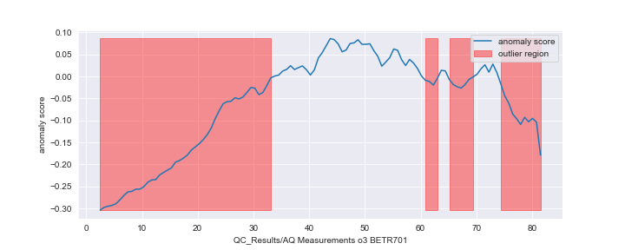

Prediction – Predicting next few days AQ measurements
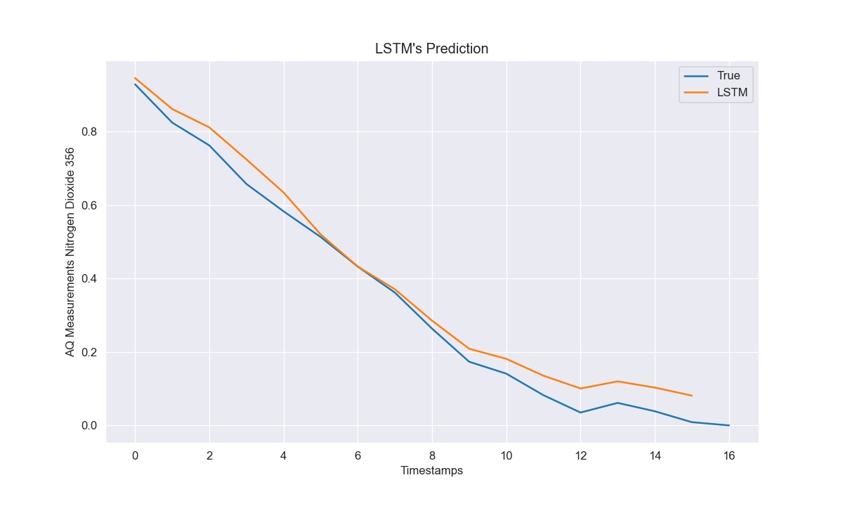
AirNode’s software can predict the next few days AQ measurements.
This can be used to optimise ventilation system or mitigation strategies
Geospatial – Analysing impacting factors on AQ measurement in local environment
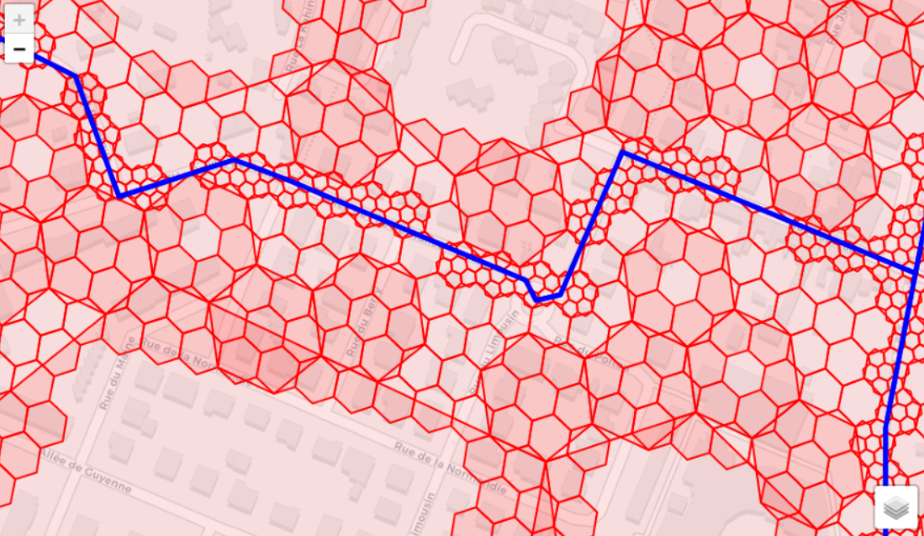
Direction of air flow with air pollutants
Force of air flows
Impacting factors along air flow to reduce or increase air pollutants (Green space, high buildings etc..)
Project Aims
Setup an AQ network on NTU campus to optimise ventilation systems
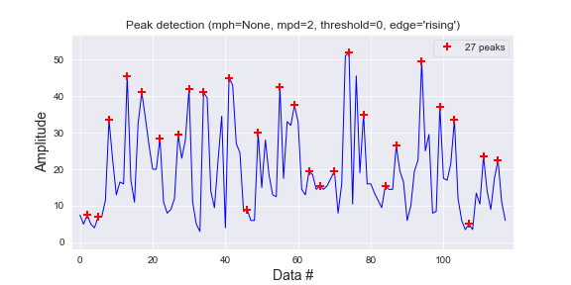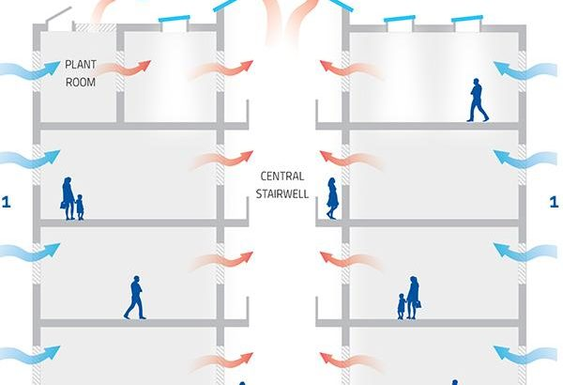
Linking emissions causation to AQ measurements
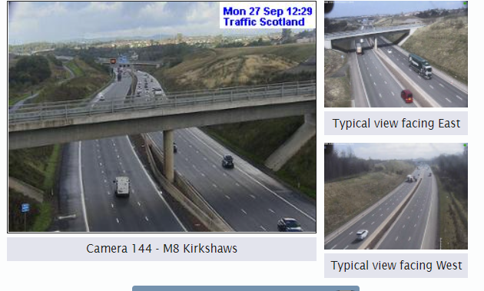
Designing optimisation strategies for avoiding of low AQ exposure.
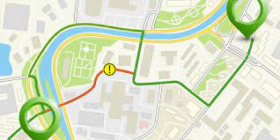

Designing mitigation strategies to specific use cases and generalising these

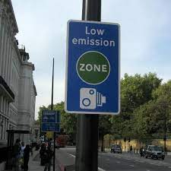

Conclusion
The NTU campus wants an AQ network and there is an opportunity for research in built environment, air pollution exposure avoidance and air pollution mitigation strategies. These would inform building architects, developers and users to gain increased indoor air quality and reduce air pollution exposure. There is an opportunity to inform transport and urban planner of optimised strategies. The AirNode software can be applied to identify irregular patterns in the AQ measurements which are caused by specific emission causations. These identification of specific emission causations can be used to design mitigation and avoiding strategies of air pollution exposure.

